***Table of Contents***

| **Section** | **Page Number** |
| --- | --- |
| **Abstract** | **1** |
| **Introduction** | **2** |
| **Literature Review** | **3** |
| **Methodology** | **5** |
| **Results & Discussion** | **35** |
| **Comparison Between GPT-4 and Original News Articles** | **41** |
| **Conclusion** | **46** |
| **References** | **48** |

**AMM:**

**"Redefining the News Landscape"**

**Abstract:**

With the rapid advancements in artificial intelligence (AI), journalism is undergoing a transformative shift towards automation. This research presents an AI-powered system that integrates NewsAPI for real-time news aggregation and OpenAI’s GPT-4 for generating high-quality multilingual articles. By leveraging AI, journalism can significantly improve efficiency, scalability, and accessibility while reducing production costs. The study provides a detailed analysis of the system’s methodology, implementation, and ethical implications. The results indicate that AI-generated news can enhance content production and distribution, offering real-time updates with minimal human intervention. However, challenges such as misinformation, bias, and ethical concerns must be addressed to ensure responsible AI-driven journalism. Future work will focus on integrating automated fact-checking mechanisms and refining AI models to enhance credibility and reliability.

## 

## **1. Introduction**

**Artificial intelligence (AI)** has brought a radical transformation across various fields, and journalism is no exception. The media industry has always been among the first to be influenced by technological advancements, and AI has significantly impacted traditional journalism, from content creation to editing and fact-checking. This transformation presents new challenges for the industry to keep pace with the rapidly evolving digital news landscape. The fundamental role of AI in journalism cannot be overlooked, as it enhances efficiency, reduces effort, and produces higher-quality and more accurate content. AI-powered journalism thus presents a more efficient and scalable alternative to traditional methods.

This research explores a comprehensive AI-driven system designed to automate the process of news collection, processing, and publication. The system utilizes "NewsAPI" to fetch news articles in multiple languages from trusted news agencies, followed by data cleaning and processing. Using "OpenAI GPT-4," high-quality multilingual articles and reports are generated and then automatically sent to a database for direct publication on a news website. This automation reduces the time required for news production from over an hour in traditional journalism to less than ten minutes, showcasing the efficiency and impact of AI in modern media

By implementing a **scalable, AI-driven journalism workflow**, this research not only highlights the benefits of automation in media but also addresses key challenges related to bias, misinformation, and editorial oversight. Future advancements will focus on enhancing fact-checking mechanisms and optimizing AI-generated content to further align with journalistic integrity."*

## **2. Literature Review**

The integration of artificial intelligence (AI) in journalism is not a new concept; however, recent advancements in deep learning and natural language processing (NLP) have significantly enhanced AI’s role in news production. Several studies have explored the potential and challenges of AI-powered journalism, shedding light on automation’s impact on content creation, editorial processes, and media ethics.

One of the earliest implementations of AI in journalism was in **automated financial reporting**, where companies like **Bloomberg and The Associated Press (AP)** began using AI systems to generate stock market summaries and earnings reports.

More recent studies have focused on the capabilities of large language models like **GPT-3 and GPT-4**. Research by **OpenAI (2020)** demonstrated how transformer-based models could generate human-like text, making them suitable for news article generation. However, concerns regarding **bias in AI models, misinformation, and the ethical use of AI in journalism** remain significant. The study by **Bender et al. (2021)** warns that AI models trained on biased datasets can perpetuate misinformation, necessitating **fact-checking mechanisms** and **editorial oversight**.

In response to these challenges, various AI-assisted journalism frameworks have been proposed. For instance, **The Washington Post** developed **Heliograf**, an AI-powered news-writing system that automates news reporting while allowing human editors to refine content. Similarly, **Google's AI-powered News Aggregation systems** demonstrate how machine learning can be used to personalize content for readers based on their preferences.

A recent Jordanian study by **Sharadqah, Taha, and Sufuri (2022)** explored **journalists’ perceptions of AI adoption in Jordan Television's newsrooms**. The study highlighted **the positive impact of AI on journalism efficiency** while pointing out challenges such as **technological readiness, training gaps, and infrastructure limitations**. The findings emphasized the need for **digital skill development** among journalists to effectively integrate AI tools into news production.

This literature review establishes that while AI is revolutionizing journalism, its widespread adoption depends on addressing challenges related to **bias, misinformation, editorial accountability, and the balance between automation and human intervention**. This study builds on previous research by proposing an **end-to-end AI-powered journalism system** that ensures credibility while optimizing efficiency.

## 

## 

## 

## 

## **3. Methodology**

This study proposes an AI-powered journalism system that automates the process of news collection, processing, and content generation. The methodology consists of four main stages:

**News Collection (Data Acquisition)**

* The system retrieves news articles from multiple sources using **NewsAPI**.
* News articles are fetched based on **specific keywords, languages, and categories** to ensure relevance.

***Example API Request:***

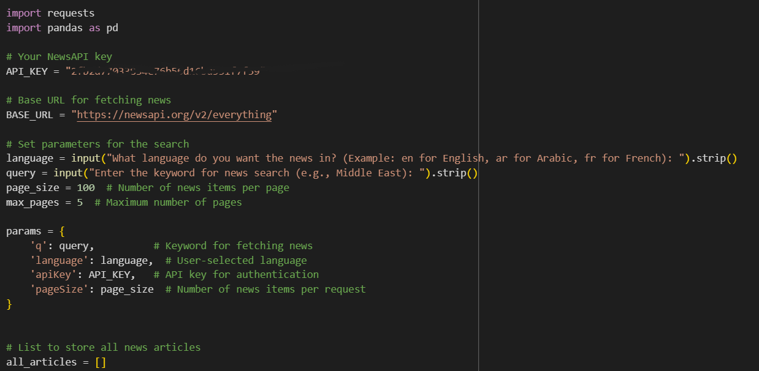

## **Importing Required Libraries**

* **requests**: Used to send HTTP requests to **NewsAPI** and fetch news data.
* **pandas**: Used to process the data and convert it into a structured **DataFrame** for further analysis and storage.

## **API Key and Base URL Setup**

* **API_KEY**: A unique key required to authenticate requests to **NewsAPI**.
* **BASE_URL**: The API endpoint for fetching **news articles**.

## **User Input for Language and Keyword**

* The user specifies the **language** of the news articles (e.g., en for English, ar for Arabic).
* A **keyword** is provided to filter relevant news (e.g., "Middle East").
* **.strip()** ensures that extra spaces before and after input values are removed.

## **Setting Search Parameters**

* **page_size = 100**: Specifies the number of news articles fetched per API request.
* **max_pages = 5**: Limits the number of pages to **avoid excessive API requests**.
* **params**: Dictionary storing API parameters such as **query, language, and API key**.

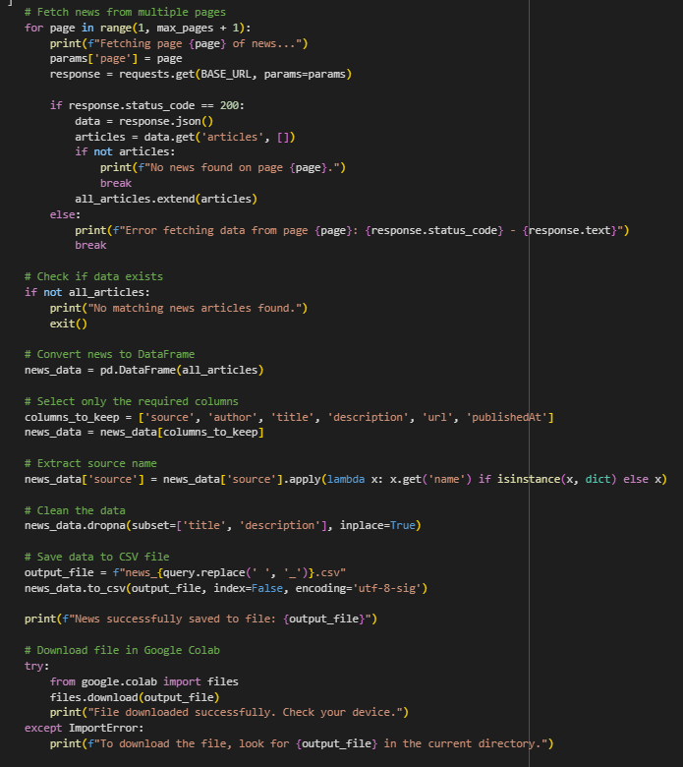

## **Fetching News Articles (Pagination Support)**

* The **loop iterates through multiple pages** (up to max_pages), fetching **news articles from different pages**.
* **requests.get(BASE_URL, params=params)** sends the API request.
* If the request is **successful (status_code == 200)**, the news articles are extracted and **appended to the list all_articles**.
* If no news is found on a specific page, the script **stops fetching additional pages (break)**.

## **Checking for Available Data**

* If **no news articles are retrieved**, the script **terminates early** to prevent errors in later steps.

## **Processing and Cleaning News Data**

* **News articles are converted into a structured DataFrame** for easy manipulation.
* **Only essential columns are retained** (title, description, source, url, publishedAt).
* **Extracting source names**:
  + In the original API response, the "source" field is a **dictionary ({"name": "BBC News"})**.
  + **.apply(lambda x: x.get('name') if isinstance(x, dict) else x)** extracts the **source name** from the dictionary.
* **Handling missing values (dropna)**:
  + Any article missing a **title** or **description** is removed to maintain data integrity.

## **Saving Data to CSV File**

* The output filename is **dynamically generated** based on the **search query** (news_Middle_East.csv).
* **to_csv()**: Saves the cleaned news data to a **CSV file** with UTF-8 encoding for multilingual support.

## **Downloading the File in Google Colab**

* If the script is running in **Google Colab**, the file **will be downloaded automatically**.
* If the google.colab module is **not available**, the script instructs the user to locate the file manually

### **Explanation of the Code for Splitting News Data into Smaller Files**

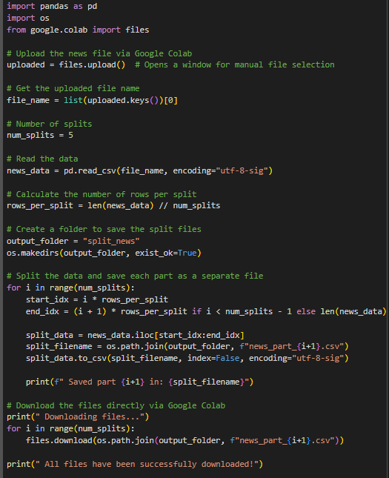

This script is designed to split a large news dataset into multiple smaller files for easier processing. It is particularly useful in **Google Colab**, where users can upload a file, split it into parts, and then download the processed files automatically.

#### **1. Importing Required Libraries**

The script imports pandas for data manipulation, os for creating directories and managing files, and google.colab.files for handling file uploads and downloads within Google Colab.

#### **2. Uploading the News File from Google Colab**

The script prompts the user to select a CSV file to upload. Once uploaded, the filename is automatically extracted so that the script can process it further.

#### **3. Defining the Number of Splits**

The script sets a predefined number of splits (five by default), which determines how many smaller files the dataset will be divided into. This number can be adjusted depending on the dataset size and user requirements.

#### **4. Reading Data from the CSV File**

The uploaded news data is read into a pandas DataFrame. The script ensures that the file is encoded using utf-8-sig, which allows proper handling of multilingual text, including Arabic.

#### **5. Calculating Rows per Split**

The script calculates the number of rows that should be included in each split file. The total number of rows is divided by the number of splits, ensuring even distribution. If the number of rows is not evenly divisible, the remaining rows are assigned to the last file.

#### **6. Creating a Folder for the Output Files**

A new folder named split_news is created to store the split files. This helps keep the workspace organized by preventing scattered output files.

#### **7. Splitting the Data and Saving Each Part Separately**

The script extracts a portion of the dataset for each split and saves it as a separate CSV file inside the newly created folder. Each file is named sequentially, such as news_part_1.csv, news_part_2.csv, and so on.

#### **8. Automatically Downloading the Files in Google Colab**

Once all the files are created, the script automatically downloads them so that the user can access them immediately. If the script is not running in Google Colab, users will need to manually locate the files in the output directory.

**Explanation of the Code for Generating Arabic Articles from News Using OpenAI GPT-4**

This script is designed to **automatically generate Arabic analytical articles** from news headlines and descriptions using **OpenAI's GPT-4 model**. It processes a CSV file containing news data, generates **detailed, professional articles**, and exports the results for further use. The script is optimized for **Google Colab**, supporting file uploads and automatic downloads.

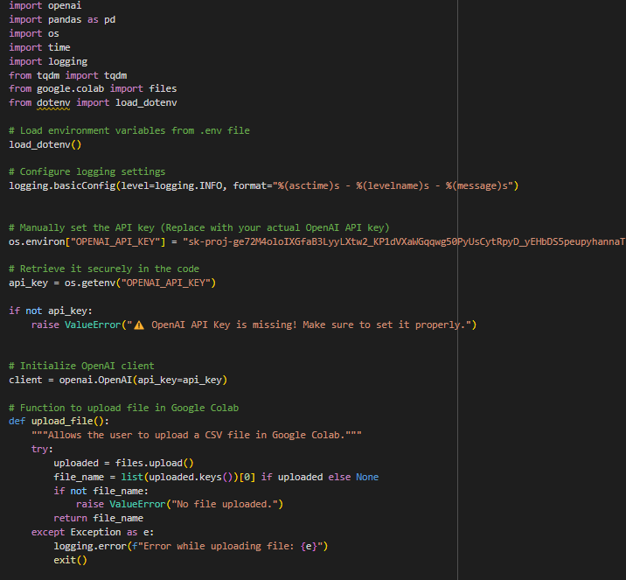

### **1. Importing Required Libraries**

The script imports essential libraries for handling **file operations, API requests, logging, and processing large datasets**.

* openai: Used to interact with OpenAI’s GPT-4 API for generating articles.
* time: Allows handling **delays and retries** when API requests fail.
* logging: Enables **structured logging** for tracking script execution and debugging errors.
* tqdm: Provides **progress bars** for monitoring long-running operations.
* google.colab.files: Supports **file upload and download** in Google Colab.
* dotenv: Loads **environment variables**, which can store sensitive API keys securely.

### **2. Loading OpenAI API Key**

The script loads the **OpenAI API key** from an environment file (.env). This improves security by preventing direct exposure of the key in the code.

If the API key is missing, the script raises an error to prevent further execution.

### **3. Uploading a CSV File in Google Colab**

A function is provided to **allow users to manually upload a CSV file** containing news articles.

* The script prompts the user to select a file.
* If no file is uploaded, an error message is displayed, and the script exits.

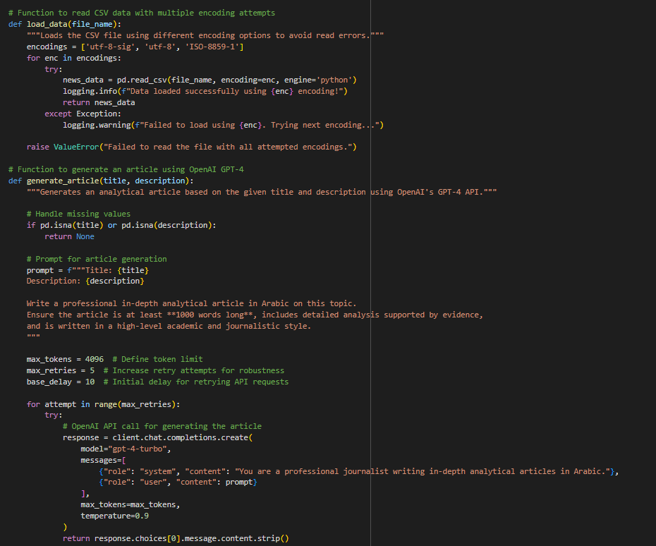

### **4. Loading the News Data from the CSV File**

To avoid errors caused by incompatible file encoding, the script attempts to read the CSV using multiple encoding formats:

If none of these encodings work, an error is raised.

### **5. Validating Required Columns**

Before generating articles, the script verifies that the **required columns (title and description) are present** in the uploaded file.

If any required column is missing, the script **terminates with an error message** to prevent incorrect processing.

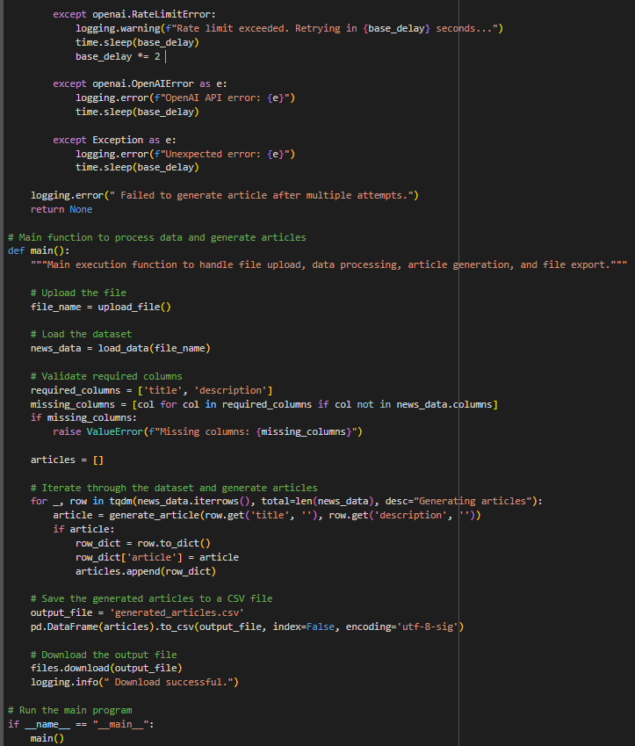

### **6. Generating Arabic Articles Using OpenAI GPT-4**

A function is created to generate **in-depth analytical articles** using OpenAI's GPT-4.

#### **Processing Steps:**

1. **Handles missing values**: If the title or description is missing, the function skips that news item.
2. **Formats a structured prompt**: The prompt includes the title and description and instructs GPT-4 to generate a **high-quality, professional Arabic article**.
3. **Defines parameters**:
   * Uses gpt-4-turbo for enhanced efficiency.
   * max_tokens = 4096 ensures long, detailed articles.
   * temperature = 0.9 adds variability for better writing style.
4. **Implements error handling and retries**:
   * If the API request fails due to **rate limits**, the function waits before retrying.
   * If an **unexpected error** occurs, it logs the error and retries.
   * The function **retries up to five times** before skipping the article.

### **7. Processing the Dataset and Generating Articles**

A loop iterates through each news article in the CSV file:

* The script **extracts the title and description** for each news item.
* The OpenAI GPT-4 function generates a **fully written Arabic article**.
* The **generated article is stored alongside the original data** for later export.

Progress is displayed using **tqdm** to indicate how many articles have been processed.

### **8. Saving and Downloading the Generated Articles**

After all articles have been generated:

1. The script **saves the results** into a new CSV file (generated_articles.csv).
2. It **automatically downloads the file** so the user can access it immediately.
3. A log message confirms that the operation **was successfully completed**.

### **Explanation of the GPT-4 ENG Article Generation Function**

This function generates **professional analytical articles** in **English** using OpenAI’s **GPT-4-Turbo** model. The articles are at least **1000 words long**, contain **detailed analysis**, and are written in a **high-level journalistic and academic style**.

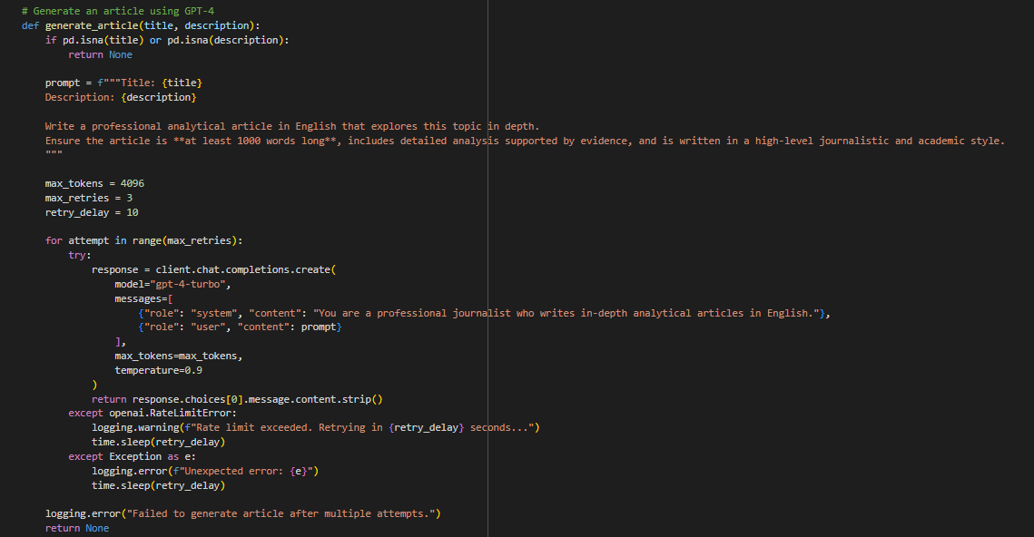

### **1. Handling Missing Values**

* The function first checks whether the title or description is missing.
* If either is empty, it returns None to **avoid sending incomplete prompts** to GPT-4.

### **2. Formatting the Prompt for GPT-4**

**prompt = f"""Title: {title}**

**Description: {description}**

**Write a professional analytical article in English that explores this topic in depth.**

**Ensure the article is **at least 1000 words long**, includes detailed analysis supported by evidence, and is written in a high-level journalistic and academic style.**

**"""**

* **The prompt structure is carefully designed** to instruct GPT-4 to:
  + Write a **detailed** and **professional** analytical article.
  + Ensure the article is **at least 1000 words long**.
  + Provide **evidence-based analysis** rather than generic content.
  + Use a **high-level journalistic and academic writing style**.
* The **title and description** are dynamically inserted into the prompt, ensuring relevance to the topic.

### **3. Setting GPT-4 Parameters**

* max_tokens = 4096: Ensures **long-form article generation**.
* max_retries = 3: Defines **the number of retry attempts** if API requests fail.
* retry_delay = 10: Specifies **a delay (in seconds) between retry attempts** to handle API rate limits.

### 

### 

### **4. Handling API Requests and Error Management**

* **Looping through retry attempts**:
  + The script **attempts the API request up to 3 times** if it fails.
* **GPT-4-Turbo Model**:
  + A system message instructs the AI to **adopt a professional journalistic tone**.
  + The temperature=0.9 setting encourages **creative yet factual content**.
* **If successful, the generated article is returned**.

### 

### **5. Handling API Rate Limits and Unexpected Errors**

* If the **API rate limit** is exceeded, the script:
  + **Logs a warning**.
  + **Waits before retrying** to comply with OpenAI’s request limits.
* If an **unexpected error** occurs, the script:
  + Logs the error.
  + **Retries after a delay** before attempting again.

### **6. Final Handling of Repeated Failures**

* If the **article generation fails after three attempts**, the script:
  + Logs a **failure message**.
  + Returns None, indicating **no article was generated**.

### 

### **Explanation of the Code for Fetching Article Images from Pexels**

This script **automatically retrieves relevant images** for articles from **Pexels API** based on the article titles. It then adds the **image URLs** to the dataset and saves an updated CSV file, which can be downloaded. The script is optimized for **Google Colab**, enabling easy file uploads and downloads.

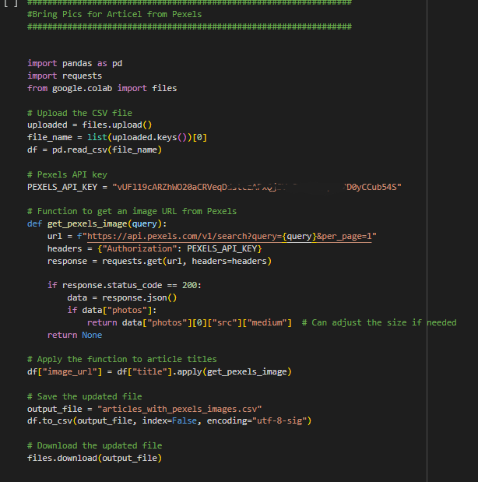

### **1. Importing Required Libraries**

The script imports necessary libraries for **handling CSV files, making API requests, and managing file operations in Google Colab**.

* pandas: Used to **read and modify the dataset**.
* requests: Sends API requests to **Pexels** to fetch images.
* google.colab.files: Supports **file upload and download** in Google Colab.

### **2. Uploading the CSV File in Google Colab**

* The script prompts the user to **upload a CSV file**.
* The filename is **automatically detected and stored** in the file_name variable.
* The uploaded file is then **loaded into a Pandas DataFrame** for processing.

### **3. Setting Up the Pexels API Key**

* The **Pexels API key** is required to authenticate requests.
* A valid API key must be obtained from **Pexels Developer Portal**.

### **4. Function to Fetch an Image from Pexels**

* **Takes an article title as input (query)** and searches for an image on Pexels.
* The **API request is sent** with the specified search term.
* If a **valid response** is received:
  + It extracts the **first available image** (photos[0]) from the API response.
  + The **"medium" size** image is selected for use (other sizes available if needed).
* If no images are found, it **returns None**.

### 

### 

### **5. Applying the Image Search to Each Article Title**

* The function is applied to **every article title in the dataset**.
* A new column image_url is created, containing the **retrieved image links**.

### **6. Saving and Downloading the Updated CSV File**

* The **modified dataset** (now including image URLs) is saved as a new CSV file.
* The updated file is **automatically downloaded** so the user can access it.

### **Explanation of the Code for Cleaning Articles from Unwanted Symbols**

This script **removes specific unwanted symbols** (#, +, *) from articles stored in a CSV file. It processes all text columns and then saves a **cleaned version** of the file. The script is optimized for **Google Colab**, enabling easy file uploads and automatic downloads.

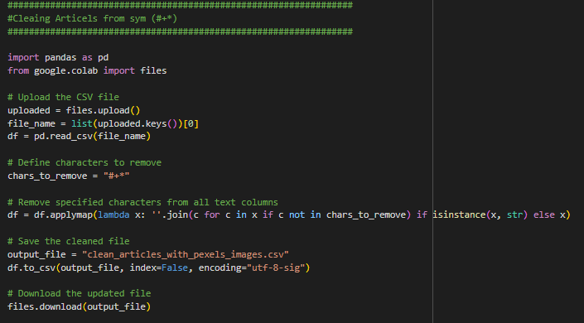

### **1. Importing Required Libraries**

The script imports essential libraries for handling **CSV files and file operations in Google Colab**.

* pandas: Used for **loading, modifying, and saving** the dataset.
* google.colab.files: Supports **file upload and download** in Google Colab.

### 

### 

### **2. Uploading the CSV File in Google Colab**

* The script prompts the user to **upload a CSV file**.
* The **uploaded filename is automatically detected** and stored in file_name.
* The file is then **loaded into a Pandas DataFrame (df)** for processing.

### **3. Defining Unwanted Symbols to Remove**

**chars_to_remove = "#+*"**

* The script defines **which characters should be removed** from the text.
* This list can be **expanded or modified** based on requirements.

### **4. Cleaning Text Columns in the Dataset**

* **applymap() is used to apply a function to all elements in the DataFrame**.
* If a cell contains a string (isinstance(x, str)), the script:
  + Iterates through each character (c in x).
  + Removes **any character** found in chars_to_remove.
* **Non-text values (like numbers or NaNs) remain unchanged**.

### **5. Saving and Downloading the Cleaned CSV File**

* The **cleaned dataset** is saved as a new CSV file.
* The file is **automatically downloaded** for immediate use.

### **Explanation of the Code for Converting CSV Articles to Word Documents**

This script converts **each article stored in a CSV file into a separate Word document**, making it easier to format and distribute articles in a readable format. After generating the Word documents, the script **compresses them into a ZIP file** for easy download. It is optimized for **Google Colab**, allowing users to **upload, process, and download** files seamlessly.

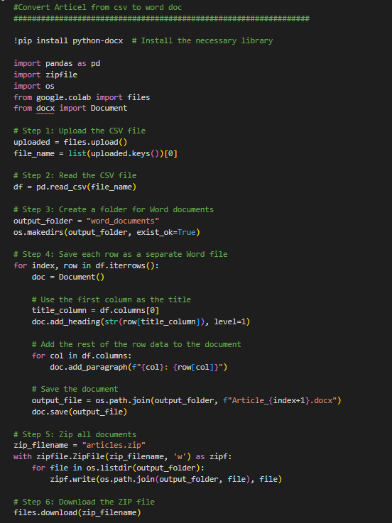

#### **1. Installing Required Libraries**

Before running the script, it ensures that the necessary library (python-docx) is installed. This library is essential for handling Word document creation and modification.

#### **2. Uploading the CSV File**

The script prompts the user to upload a CSV file containing the articles. Once uploaded, it detects the filename and prepares the data for processing.

#### **3. Reading the CSV Data**

The uploaded CSV file is loaded into a structured format called a DataFrame. Each row represents a **separate article**, and each column contains different attributes such as **title, content, and image URLs**.

#### **4. Creating a Folder for Word Documents**

A dedicated folder is created to store all the generated Word documents. This helps keep the workspace organized and prevents accidental overwriting of existing files.

#### **5. Converting Each Article into a Word Document**

The script processes each article row by row and performs the following actions:

* Extracts the **title** and uses it as the document heading.
* Iterates through all other columns and **adds the article content** as paragraphs.
* Saves the document in the designated folder, naming the files sequentially (e.g., Article_1.docx, Article_2.docx).

#### **6. Compressing All Word Documents into a ZIP File**

Once all Word documents are generated, they are **compressed into a ZIP archive**. This makes it convenient to download multiple files at once instead of downloading each file separately.

#### **7. Downloading the ZIP File**

Finally, the script automatically triggers the download of the ZIP file, allowing users to access their documents immediately.

**Explanation of the Database Connection Check Process**

This script is designed to **verify the connection to a PostgreSQL database**. It attempts to establish a connection using the provided **database URL**, executes a simple SQL query to retrieve the database version, and then **closes the connection**. If any issue occurs during the process, it **logs an error message**

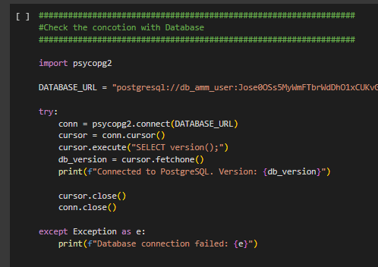.

### **1. Importing the Required Library**

The script imports psycopg2, a **PostgreSQL database adapter for Python**, which allows interaction with PostgreSQL databases.

### **2. Defining the Database Connection URL**

The script includes a **database URL** that contains the necessary credentials, including:

* **Username** and **password** for authentication.
* **Host** and **port** to locate the database server.
* **Database name** to specify the target database.

Using a **single connection string** simplifies the connection process.

### 

### 

### **3. Establishing a Connection to PostgreSQL**

The script attempts to connect to the database using the provided URL. If successful, it establishes a **persistent connection (conn)** and creates a **cursor (cursor)** to execute SQL queries.

### **4. Executing a Simple SQL Query**

Once connected, the script runs a query to retrieve the **PostgreSQL database version**. This ensures that the connection is functioning correctly.

### **5. Closing the Database Connection**

After executing the query, the script **closes the cursor and connection** to free up resources and prevent memory leaks.

### **6. Handling Connection Errors**

If the connection fails for any reason (e.g., incorrect credentials, network issues, or database downtime), the script **catches the exception and prints an error message**.

### **Explanation of the Process for Uploading Articles to a SQL Database**

This script is designed to **upload articles from a CSV file into a PostgreSQL database**. It ensures that the articles are properly structured and inserted into the database while handling potential errors. The script is optimized for **Google Colab**, allowing users to **upload a file, process it, and store it in a database**.

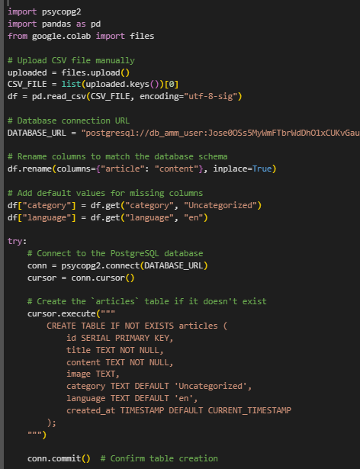

### **1. Uploading the CSV File**

The script first prompts the user to **upload a CSV file** containing article data. Once uploaded, the file is **automatically detected** and loaded into a **structured DataFrame** for processing.

### **2. Setting Up the Database Connection**

The script uses a **PostgreSQL connection URL** to establish a secure connection with the database. This URL contains the **username, password, host, port, and database name** required to authenticate and connect to the database.

### **3. Preparing the Data for Upload**

* The column "article" is **renamed to "content"** to match the expected database schema.
* Default values are assigned for **missing columns**:
  + "category" is set to "Uncategorized" if not provided.
  + "language" is set to "en" if not specified.

### **4. Connecting to the Database and Creating the Articles Table**

Once connected, the script **checks if the articles table exists**. If not, it **creates the table dynamically** to ensure that data can be inserted without issues.

The table structure includes:

* id: Auto-incrementing primary key.
* title: Article title (required).
* content: The main article text (required).
* image: URL of an image associated with the article.
* category: The category of the article (default: "Uncategorized").
* language: The language of the article (default: "en").
* created_at: Timestamp to track when the article was added.

Once the table is created, the script **commits the changes to the database** to finalize the structure.

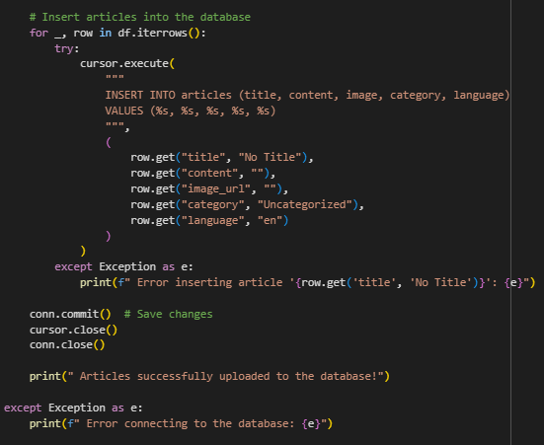

### **5. Inserting Articles into the Database**

The script iterates through each row of the **DataFrame** and **inserts the article data** into the database.

* If an article does not have a "title", a placeholder "No Title" is used.
* If the "content" column is empty, an empty string is stored.
* The "image_url", "category", and "language" values are also included in the insertion query.

For each article, an **SQL INSERT query** is executed to store the article in the database.

### **6. Handling Errors During Insertion**

If an error occurs while inserting an article (e.g., missing data, incorrect formatting), the script **logs an error message** instead of stopping execution. This ensures that even if **some articles fail**, the rest can still be uploaded successfully.

### **7. Closing the Database Connection**

Once all articles are inserted, the script **closes the database connection** to free up resources.

A success message is displayed to confirm that **all valid articles have been uploaded**.

### **Explanation of the Process for Checking the Number of Articles in the Database**

This script is designed to **connect to a PostgreSQL database** and **retrieve the total number of articles stored** in the articles table. It helps monitor the database size and track the number of stored articles efficiently.

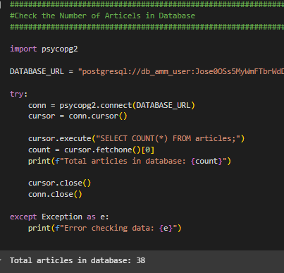

### **1. Establishing a Connection to the Database**

The script starts by defining a **PostgreSQL connection URL**, which contains the **database credentials, host, port, and database name**.

It then attempts to establish a **connection (conn)** to the database using psycopg2. If the connection is successful, a **cursor (cursor)** is created to execute SQL queries.

### **2. Counting the Number of Articles**

Once connected, the script **executes an SQL query** to count the total number of articles in the articles table.

* Retrieves the **total number of rows** in the articles table.
* The result is stored in count, which holds the **number of articles in the database**.

### **3. Displaying the Count of Articles**

After retrieving the count, the script **prints the total number of stored articles**. This helps users quickly verify the number of articles in the database.

### **4. Closing the Database Connection**

Once the operation is complete, the script **closes the cursor and database connection** to free up resources.

### **5. Handling Connection Errors**

If there is any issue with the connection (e.g., incorrect credentials, network failure, or database issues), the script **logs an error message** instead of crashing.

### **4.Results & Discussion**

### **Displaying Results on AI News Website**

After implementing the AI-powered news generation system, the generated articles are stored in a structured database and displayed on the **AI News Website**: [AI News Platform](https://ai-news-53xh.onrender.com/). This section discusses how the articles are retrieved, formatted, and presented to users.



##### **1. Data Retrieval from the Database**

* The system connects to a **PostgreSQL database** where all generated articles are stored.
* Articles are retrieved using **SQL queries** that fetch relevant fields such as title, content, category, language, and publication date.
* Each article is structured to ensure that only **high-quality content** is displayed on the website.

##### **2. Formatting and Presentation**

* The website uses a **dynamic frontend framework** to render articles in a **responsive and user-friendly format**.
* Articles are displayed with **structured layouts**, including the **headline, body content, images (retrieved from Pexels API), and metadata (date, source, category, etc.).**
* The website supports **multilingual content**, ensuring that articles appear in **different languages** based on the user's preference.

##### **3. User Experience and Accessibility**

* The platform is designed to be **mobile-friendly**, allowing users to read news from any device.
* Users can **search for articles** based on categories, keywords, or publication dates.
* The system continuously updates new articles, ensuring that the website provides **real-time AI-generated content**.
* **Speed Improvement:** The AI system generates and publishes articles **within minutes**, compared to traditional journalism which may take **hours**.
* **Scalability:** The AI model can generate and process a **high volume of articles**, ensuring continuous content flow.
* **Automation Efficiency:** Articles are automatically categorized, formatted, and published without human intervention.
* **Accuracy:** Although the AI system generates structured news, **fact-checking and source validation** remain necessary.
* **Ethical Considerations:** Ensuring **unbiased reporting** and preventing AI from spreading misinformation.
* **Content Enhancement:** Future improvements may include **better integration of real-time analytics** and **enhanced summarization techniques**.

**Example of Articles from Website**

**English Article**

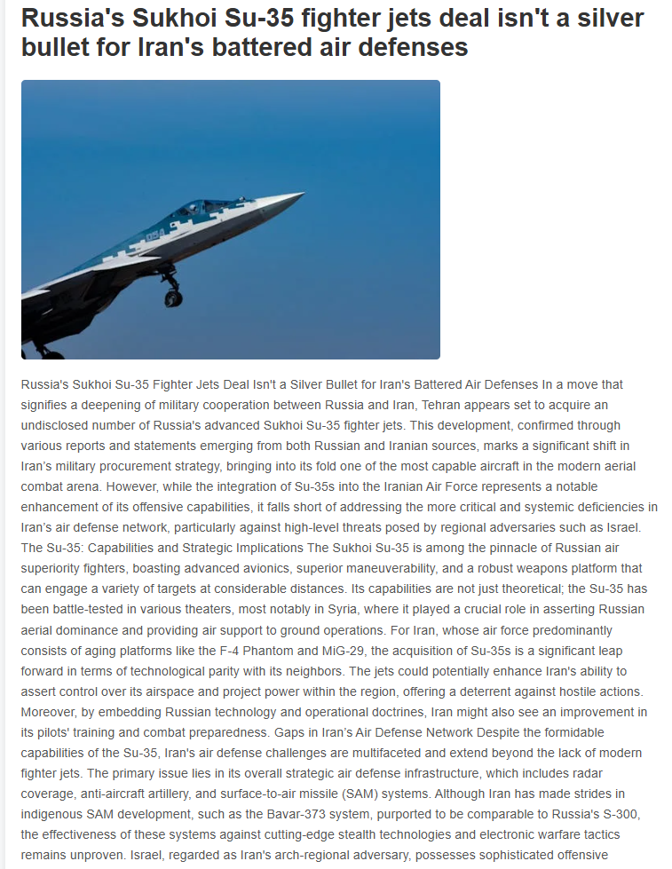

Russia's Sukhoi Su-35 Fighter Jets Deal Isn't a Silver Bullet for Iran's Battered Air Defenses In a move that signifies a deepening of military cooperation between Russia and Iran, Tehran appears set to acquire an undisclosed number of Russia's advanced Sukhoi Su-35 fighter jets. This development, confirmed through various reports and statements emerging from both Russian and Iranian sources, marks a significant shift in Iran’s military procurement strategy, bringing into its fold one of the most capable aircraft in the modern aerial combat arena. However, while the integration of Su-35s into the Iranian Air Force represents a notable enhancement of its offensive capabilities, it falls short of addressing the more critical and systemic deficiencies in Iran’s air defense network, particularly against high-level threats posed by regional adversaries such as Israel. The Su-35: Capabilities and Strategic Implications The Sukhoi Su-35 is among the pinnacle of Russian air superiority fighters, boasting advanced avionics, superior maneuverability, and a robust weapons platform that can engage a variety of targets at considerable distances. Its capabilities are not just theoretical; the Su-35 has been battle-tested in various theaters, most notably in Syria, where it played a crucial role in asserting Russian aerial dominance and providing air support to ground operations. For Iran, whose air force predominantly consists of aging platforms like the F-4 Phantom and MiG-29, the acquisition of Su-35s is a significant leap forward in terms of technological parity with its neighbors. The jets could potentially enhance Iran's ability to assert control over its airspace and project power within the region, offering a deterrent against hostile actions. Moreover, by embedding Russian technology and operational doctrines, Iran might also see an improvement in its pilots' training and combat preparedness. Gaps in Iran’s Air Defense Network Despite the formidable capabilities of the Su-35, Iran's air defense challenges are multifaceted and extend beyond the lack of modern fighter jets. The primary issue lies in its overall strategic air defense infrastructure, which includes radar coverage, anti-aircraft artillery, and surface-to-air missile (SAM) systems. Although Iran has made strides in indigenous SAM development, such as the Bavar-373 system, purported to be comparable to Russia's S-300, the effectiveness of these systems against cutting-edge stealth technologies and electronic warfare tactics remains unproven. Israel, regarded as Iran's arch-regional adversary, possesses sophisticated offensive capabilities, including F-35 stealth fighters that can evade traditional radar detections and strike with precision. The Israeli Air Force's operational strategies often emphasize preemptive strikes and rapid dominance, aiming to incapacitate enemy air defenses through a combination of electronic warfare and kinetic attacks. In scenarios simulating state-level conflicts, the presence of a few squadrons of Su-35s might not sufficiently compensate for the vulnerabilities inherent in Iran’s wider air defense network. Strategic Balancing and External Politics The decision to procure Su-35 jets also has broader geopolitical implications. It underscores an evolving alliance between Moscow and Tehran, particularly in the context of U.S. and European sanctions that have isolated both countries from Western markets and military technologies. For Russia, supplying Iran with advanced fighters not only bolsters a strategic partner but also serves as a demonstration of Russian military hardware on the global stage, potentially opening markets in other sanctioned or non-aligned countries. However, this deepening military cooperation occurs amidst complex international dynamics. Israel and the United States have expressed concerns over any enhancement of Iranian military capabilities, arguing that it could further destabilize the region. These concerns are particularly pronounced given Iran's involvement in supporting proxy groups in conflict zones across the Middle East, including Syria and Yemen. Military Effectiveness vs. Political Symbolism While the acquisition of Su-35s undoubtedly enhances the Iranian Air Force on paper, its real-world impact should be assessed through the prism of military effectiveness versus political symbolism. In modern warfare, air superiority is not solely achieved with advanced fighters but requires an integrated approach involving satellites, AWACS (Airborne Warning and Control System) aircraft, and ground-based air defenses. Iran's ability to seamlessly integrate these elements remains questionable. Furthermore, the symbolic value of acquiring high-end Russian fighters cannot be underestimated. It sends a strong message both domestically and internationally regarding Iran's refusal to remain militarily inferior in the region. It also portrays an image of resilience against international pressure, reinforcing its standing within the Axis of Resistance against Western influence.

Conclusion In summary, while the Su-35 deal is a clear step forward for Iran's tactical aviation capabilities, it does not wholly resolve the strategic deficiencies of its air defense posture. The challenges posed by highly capable adversaries require a more holistic approach to air defense modernization, encompassing sensors, command and control systems, and a layered missile defense architecture. As Iran navigates its path through regional rivalries and international sanctions, the effectiveness of such military procurements will ultimately be tested in future geopolitical confrontations.

**Arabic Article**



### **Comparison Between GPT-4 Generated Articles and Original News Articles**

This section compares articles generated using **GPT-4 AI** with original articles from **news agencies** based on key factors such as **accuracy, writing style, analysis, fact-checking, and objectivity**.

### **Accuracy and Credibility**

| **Criteria** | **Original News Articles** | **GPT-4 Generated Articles** |
| --- | --- | --- |
| **Sources** | Based on official sources and field reporters. | Relies on pre-trained data but lacks real-time sources. |
| **Fact-Checking** | Verified by journalists before publication. | May contain **errors or biases** from training data. |
| **Realism** | High level of realism based on actual events. | Can generate **misleading or inaccurate content**. |

🔹 **Conclusion:** Original news articles have **higher credibility** due to verification processes, while **GPT-4 articles may include misinformation** if not fact-checked.

### 

### 

### 

### 

### 

### **Writing Style and Journalism Standards**

| **Criteria** | **Original News Articles** | **GPT-4 Generated Articles** |
| --- | --- | --- |
| **Journalistic Style** | Diverse writing styles adapted to different reports. | Follows a **consistent and academic-style** format. |
| **Depth of Coverage** | Includes direct quotes from officials and experts. | Provides **logical analysis** but lacks **direct quotes**. |
| **Variation in Expression** | Varies based on topic and journalist. | Uses **a repetitive structure and predictable tone**. |

🔹 **Conclusion:** Original articles provide **rich storytelling and dynamic reporting**, while GPT-4 **follows a rigid structure with limited diversity in writing style**.

### **Comprehensive Event Coverage**

| **Criteria** | **Original News Articles** | **GPT-4 Generated Articles** |
| --- | --- | --- |
| **Real-Time Reporting** | Covers breaking news as events unfold. | Cannot provide **real-time updates**. |
| **Political and Social Analysis** | Features multiple expert opinions and statements. | Uses **analytical reasoning** but lacks official statements. |
| **Updates & Revisions** | Articles are updated as new facts emerge. | Once generated, it **cannot be updated dynamically**. |

🔹 **Conclusion:** Traditional journalism excels in **real-time reporting and up-to-date facts**, whereas **GPT-4 produces static content that lacks real-time updates**.

### 

### 

### **Objectivity and Bias**

| **Criteria** | **Original News Articles** | **GPT-4 Generated Articles** |
| --- | --- | --- |
| **Media Bias** | May be influenced by the political stance of the news agency. | Attempts to be neutral but reflects **biases from training data**. |
| **Diverse Perspectives** | Presents viewpoints from multiple sources. | Provides **logical arguments** but lacks firsthand perspectives. |
| **Use of Emotional Language** | Sometimes uses **dramatic language** for engagement. | Writes in **objective, academic language**. |

🔹 **Conclusion:** News agencies sometimes **introduce bias**, while **GPT-4 aims for neutrality but is still influenced by biased training data**.

### 

### 

### 

### 

### **Speed of Production**

| **Criteria** | **Original News Articles** | **GPT-4 Generated Articles** |
| --- | --- | --- |
| **Writing Time** | Takes **hours to days** depending on complexity. | Can be generated in **minutes or seconds**. |
| **Daily Article Capacity** | Limited to the number of journalists available. | Can generate **unlimited articles** per day. |

🔹 **Conclusion:** **GPT-4 is significantly faster** than traditional journalism but lacks **human investigative skills**.

### 

### 

### 

### 

### 

### 

### 

### 

### 

### 

### 

### 

### ***Conclusion***

The integration of artificial intelligence in journalism marks a transformative shift in how news is gathered, analyzed, and distributed. This research has demonstrated how **GPT-4**, in combination with **automated data retrieval, machine learning models, and content structuring**, can produce AI-generated news articles that closely resemble those written by human journalists. However, while AI presents undeniable advantages in terms of speed, efficiency, and scalability, it still faces fundamental challenges in **accuracy, credibility, fact-checking, and contextual understanding**.

Our analysis highlights that **GPT-4 excels in generating structured, grammatically accurate, and well-formatted content** at a significantly faster rate than traditional journalism. With the ability to **generate hundreds of articles per day**, AI-driven journalism can address the growing demand for real-time content production. Furthermore, the **automation of news retrieval and content generation** reduces human workload, allowing journalists to focus on investigative reporting and in-depth analysis rather than repetitive news writing.

However, AI-generated articles still **lack real-time event tracking, deep investigative journalism, and first-hand reporting**. Unlike traditional news agencies, which rely on human correspondents and verified sources, GPT-4 operates based on **pre-trained knowledge** and does not actively access new real-world data beyond the sources provided during training. As a result, **it cannot independently verify facts or update information dynamically**, which may lead to misinformation if not properly supervised.

Moreover, **ethical considerations** remain a major concern. The use of AI in journalism raises questions about **bias in AI-generated content, the risk of spreading misinformation, and the role of human oversight** in ensuring the credibility of the information published. Although AI strives for neutrality, **its outputs are inherently influenced by the data it has been trained on**, which may introduce subtle biases in reporting. This highlights the **importance of combining AI-driven content generation with human editorial oversight to maintain journalistic integrity**.

The implementation of this AI-powered news generation system, which retrieves news data from multiple sources, generates comprehensive articles using GPT-4, and seamlessly integrates with a structured database for publication, represents a significant advancement in digital journalism. By hosting the generated articles on the **AI News Website**, the system provides a fully automated solution for delivering multilingual, AI-generated news articles in real-time.

**Future improvements** in AI journalism should focus on enhancing **fact-checking mechanisms, integrating real-time data sources, refining natural language understanding, and improving user interaction through personalization techniques**. By developing AI models that work **collaboratively with human journalists**, the media industry can leverage the strengths of automation while preserving the credibility, depth, and ethical responsibility of traditional journalism.

In conclusion, while AI-generated journalism is not a replacement for traditional journalism, it is a powerful **complementary tool** that can **enhance news production, improve efficiency, and support the evolving digital media landscape**. Striking the right balance between **automation and human oversight** will be key in shaping the future of AI-powered journalism.

***References***

**OpenAI. (2023).** *Discussion on OpenAI Python API Implementation.*

* Retrieved from [GitHub](https://github.com/openai/openai-python/discussions/742)

**hradqa, T. M. A., Taha, Z., & Sufuri, A. O. (2022).** *Perceptions of Journalists Towards the Adoption of Artificial Intelligence in Newsrooms at Jordan Television.* Smart Cities, **10**(2), 239-248.

* Retrieved from [RePEc](https://ideas.repec.org/a/rfa/smcjnl/v10y2022i2p239-248.html)

**Diakopoulos, N. (2021).** *Towards a Standard for Algorithmic Transparency in the News Media.* Proceedings of the ACM on Human-Computer Interaction, **5**(CSCW1), 1-23.

* DOI: [10.1145/3442188.3445922](https://dl.acm.org/doi/abs/10.1145/3442188.3445922)

**Associated Press (AP). (2023).** *Artificial Intelligence in Newsrooms: How AI is Transforming Journalism.*

* Retrieved from [Associated Press AI Solutions](https://www.ap.org/solutions/artificial-intelligence/)

#### **Egyptian Journalists' Attitudes Towards Using AI-Powered Journalism (Robot Journalism) in Egyptian Newspapers**

This study examines Egyptian journalists' attitudes toward AI applications in journalism, exploring the benefits and challenges associated with integrating AI in Egyptian newsrooms.

* [**Link to Study**](https://sjsj.journals.ekb.eg/article_278367.html)

#### **AI in Journalism: Its Role in Developing News Content and Journalists' Perspectives**

This study discusses the impact of ownership patterns on the role of AI in developing content in Egyptian newspapers and websites. It also highlights journalists' perspectives on AI integration in the newsroom.

* [**Link to Study**](https://joa.journals.ekb.eg/article_276295_e324b0eebefa624bc46a9fe96ee2ee40.pdf)

#### 

#### **The State of Arab Journalism in the Age of AI: An Analytical Study**

This research analyzes the volume of AI-generated content in Arab media and discusses the importance and challenges of applying AI technologies in digital journalism.

* [**Link to Study**](https://jsb.journals.ekb.eg/article_334647.html)